The checkbox is just another form of a parameter. And there's a rule that the checkbox always has to be of data type C, a character with a length of 1. And the content that gets stored in that parameter, will either be an x, for when it's checked, or it will be blank.

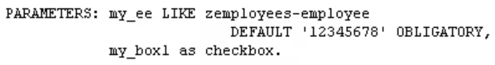

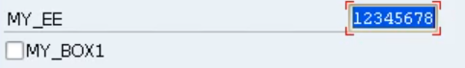

it's a checkbox, but the label for the checkbox is now on the right-hand side, with the entry field on the left.

If we don't enter a value, in other words we don't click the box, then my box one parameter, the variable will hold a blank character. If we do tick it, it's going to hold a value of X.

Now radio buttons are another common method of controlling the values that get stored in our fields.

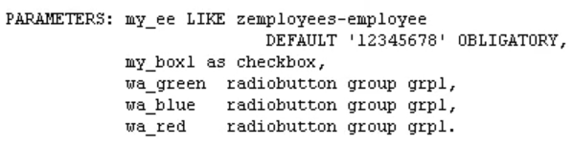when it comes to radio buttons, they're very similar to checkboxes, but checkboxes, they are individual parameters in their own right. So, you can have many checkboxes and select many checkboxes on the screen. But radio buttons have to belong to a group in which only one radio button can be selected at any one time. And the way we define radio buttons, is very similar to checkboxes. They have to be of data types C, and a length of 1. And because they belong to a group,

let's say a group of three radio buttons, we would define three individual parameter fields.

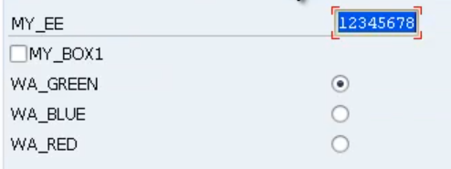

by selecting any of the radio buttons, we can only ever have one value. And that just about sums up the parameter statements.